**Ubuntu Commands**

**1.Uname:**

The uname (UNIX name) command in Linux is a simple yet powerful tool that offers information about a [Linux](https://phoenixnap.com/kb/what-is-linux) machine's [operating system](https://phoenixnap.com/glossary/operating-system) and hardware platform.

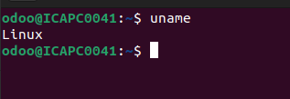

**2.whoami:**

The whoami command in Linux displays the username of the user who is currently logged in.

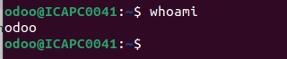

**3.cd:**

The cd command allows you to change directories in Linux, making it easier to navigate through the file system and manage your files efficiently.

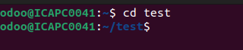

**4.pwd:**

The pwd command in Ubuntu prints the current working directory's full path.

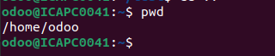

**5.ls:**

The ls command in Linux lists the contents of a directory, including files and directories.



**6.clear:**

We can clear our terminal by using shortcut `CTRL+L` or clear command.

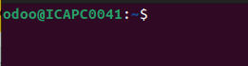

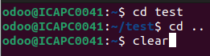

**7.cp:**

'cp' means copy. 'cp' command is used to copy a file or a directory.

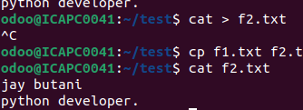

**8.cat:**

The cat (concatenate) command in Linux displays file contents. It reads one or multiple files and prints their content to the terminal. cat is used to view file contents, combine files, and create new files.

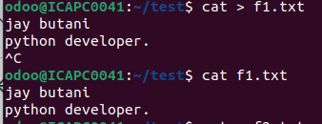

**9.head:**

The 'head' command displays the starting content of a file. By default, it displays starting 10 lines of any file.

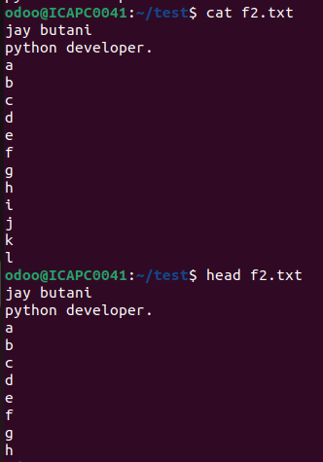

**10.tail:**

Linux tail command is used to display the last ten lines of one or more files.

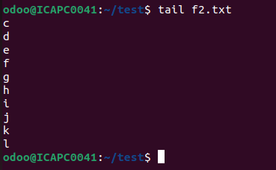

**11.mv:**

Linux mv command is used to move existing file or directory from one location to another. It is also used to rename a file or directory. If you want to rename a single directory or file then 'mv' option will be better to use.



**12.touch:**

The touch command in Linux is used to create empty files or update the timestamps of existing files.



**13.mkdir:**

The mkdir command in Linux creates new directories, or folders, on your computer.



**14.rm:**

The rm command in Linux is used to remove files, directories, and symbolic links from the file system.



**15.rmdir:**

The rmdir command in Linux is used to remove empty directories from a system.



**16.ps:**

The ps command is used to view currently running processes on the system. It helps us to determine which process is doing what in our system, how much memory it is using, how much CPU space it occupies, user ID, command name, etc .

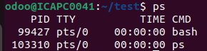

**List of all running Process:**

Command: ps -aux

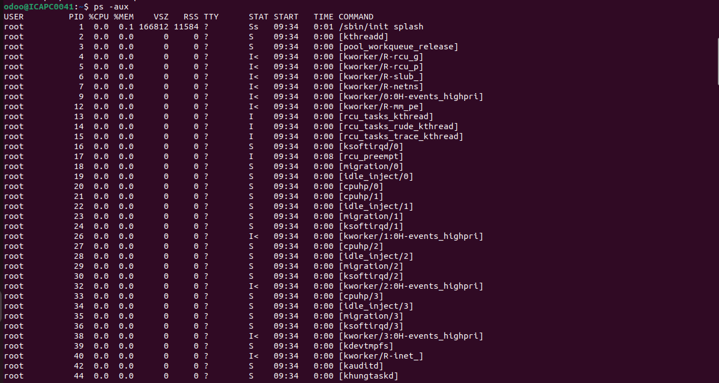

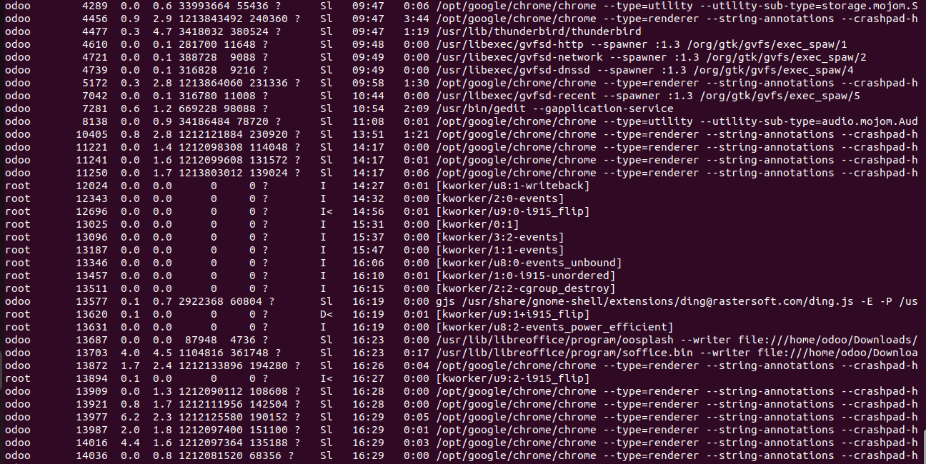

**List processes for a specific user:**

Command: ps -u user_name

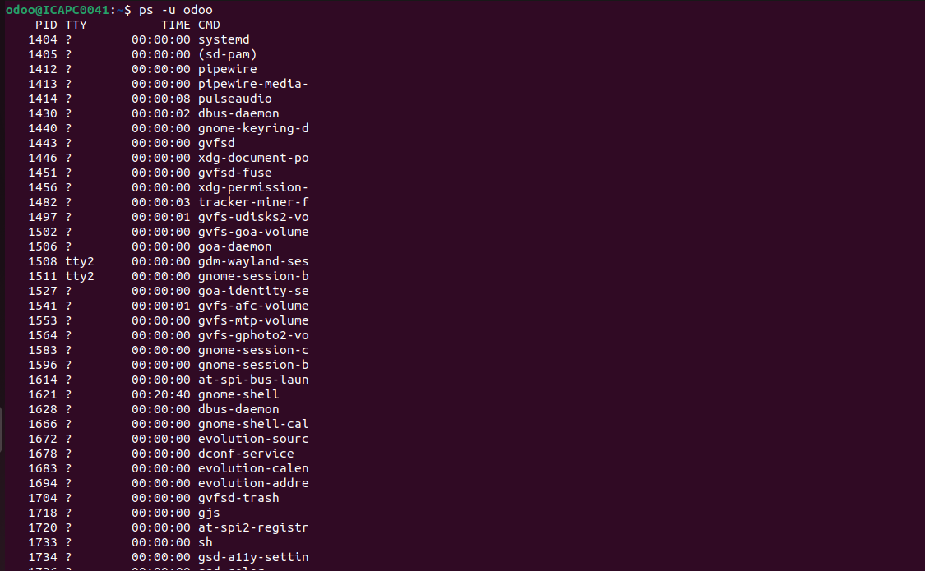

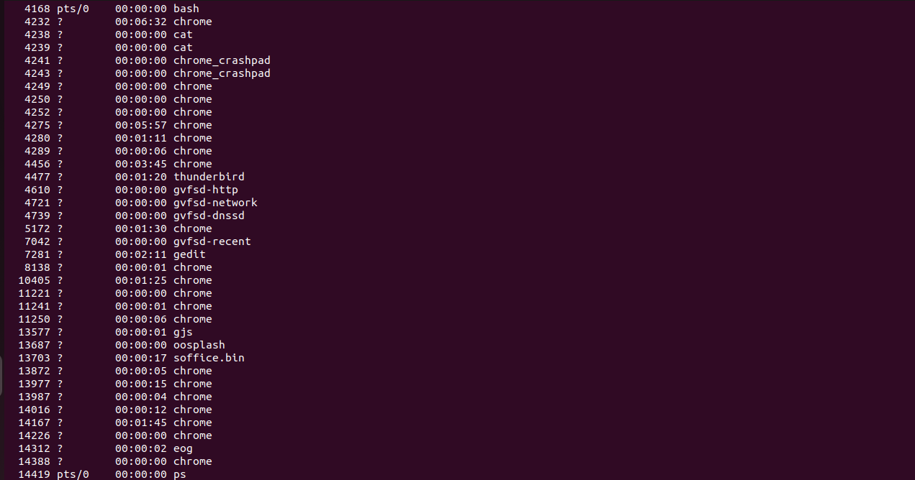

**17.kill:**

It is used for manually terminating the processes. The behaviour of the kill command is slightly different among the shells and the */bin/kill* standalone executable.

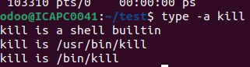

**Kill a specific process:**

Command: kill PID

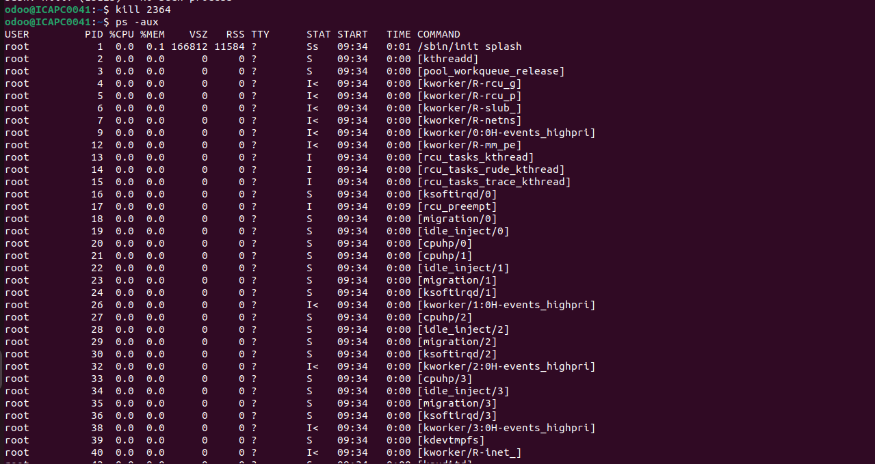

**Stop a process:**

Use the pkill command with the process name. The basic syntax is pkill process_name.

Command: killall -u user_name

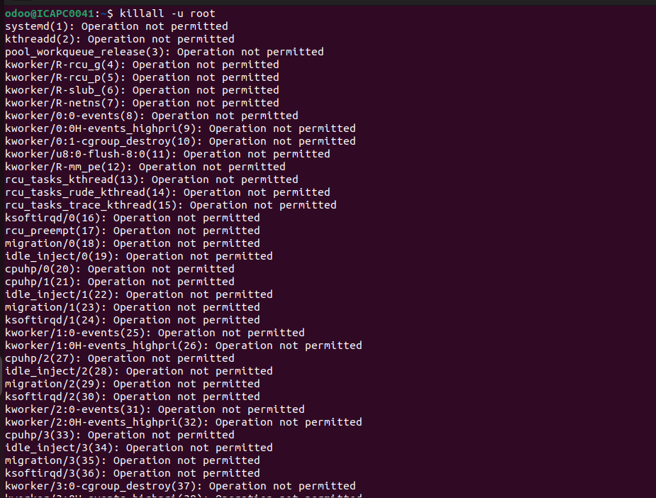

**18.chmod & chown:**

The "chmod" command modifies the read, write, and execute permissions of specified files and the search permissions of specified directories.

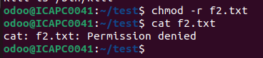

Linux chown command is used to change a file's ownership, directory, or symbolic link for a [user](https://www.javatpoint.com/linux-users) or [group](https://www.javatpoint.com/linux-groups). The chown stands for change owner. In [Linux](https://www.javatpoint.com/linux-tutorial), each file is associated with a corresponding owner or group.

**Giving access to a file:**

Command: chmod +rwx filename to add permissions.

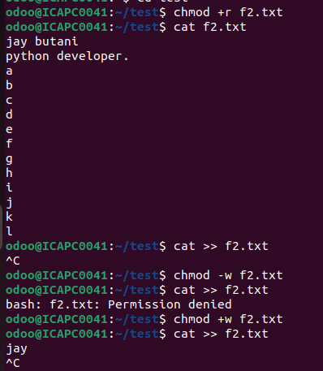

**Changing the owner of a file or directory:**

Command: chown -c ownername filename or directory

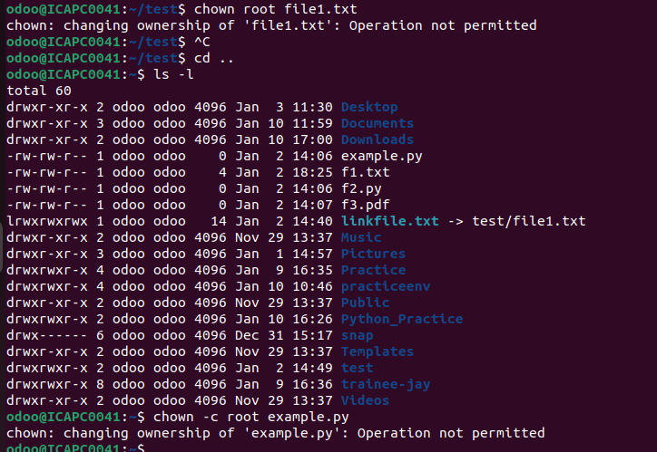

**19.apt:**

apt provides a high-level Command Line Interface (CLI) for the APT package management system, offering a user-friendly interface intended for interactive use. It simplifies common tasks like installation, upgrades, and removal, with better defaults than more specialized tools like apt-get and apt-cache.

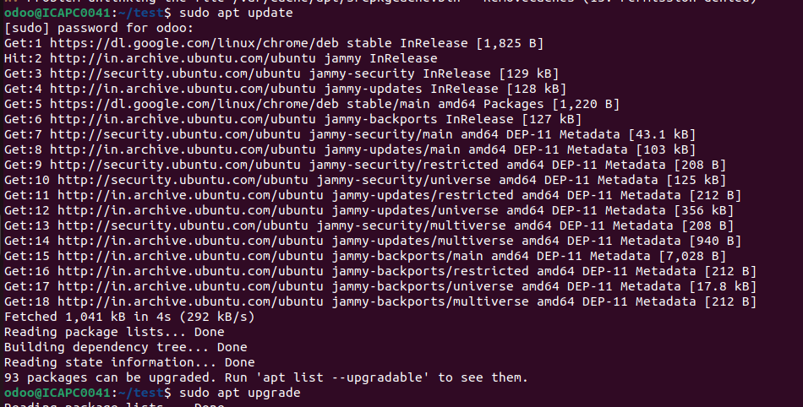

**20.apt-get:**

An older tool with a low-level interface that gives users more control over package management. It's a good choice for advanced users or those who need more control, or for scripting purposes. Apt-get has more options than apt, which can be useful for writing low-level scripts and tools.

**21.history:**

The history command in Linux allows users to view and manipulate the history of commands that have been entered. It can be used to quickly access and reuse previously executed commands.

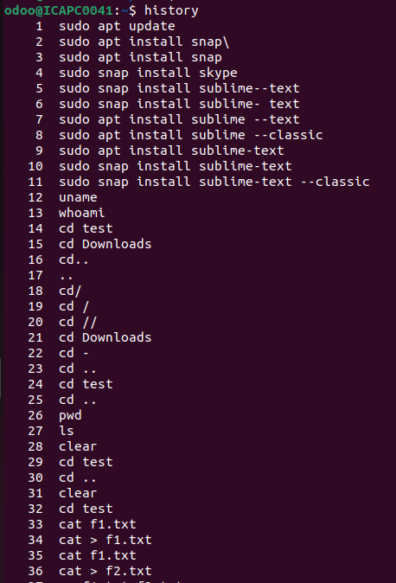

**22.nano:**

Nano is a command-line text editor in Linux that can be used for basic text editing tasks.

* **Open a file**: Type nano filename to open the file for editing
* **Save**: Press Ctrl+O to save the current file
* **Exit**: Press Ctrl+X to exit nano
* **Move cursor**: Use the arrow keys to move the cursor
* **Page navigation**: Press Ctrl+V to move down one page or Ctrl+Y to move up one page
* **Search**: Press Ctrl+W to search for a string of text
* **Cut and paste**: Press Ctrl+K to cut the current line and Ctrl+U to paste the cut text
* **Select text**: Move the cursor to the beginning of the text and press Alt+a to set a selection mark
* **Spell check**: Install the spell package to check the spelling of a particular line

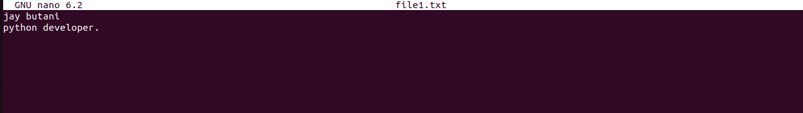

**23.ifconfig:**

The command ifconfig stands for interface configurator. This command enables us to initialize an interface, assign IP address, enable or disable an interface. It display route and network interface.

You can view IP address, MAC address and MTU (Maximum Transmission Unit) with ifconfig command.

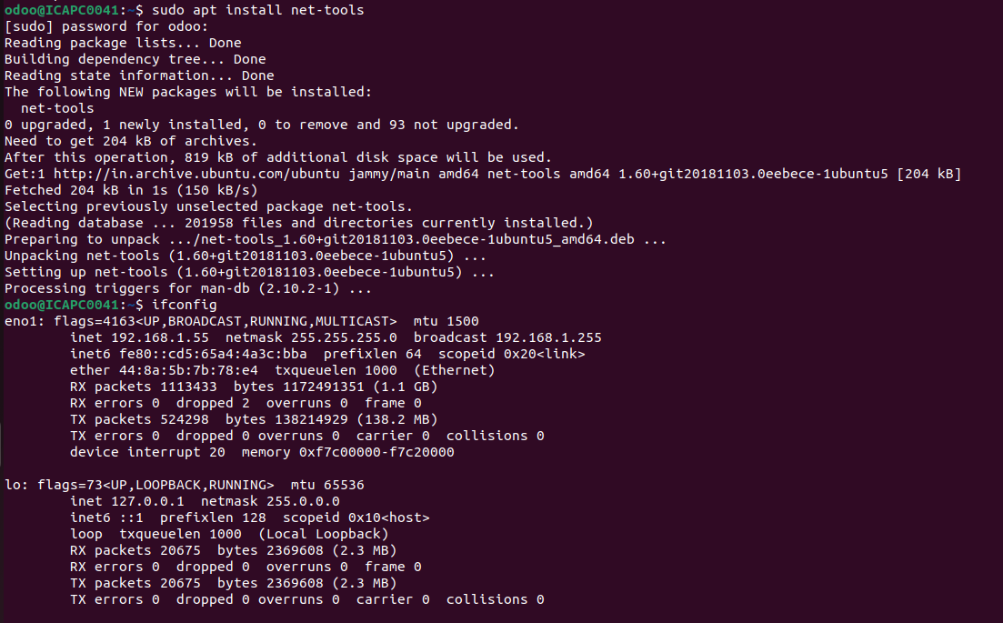

**24.ping:**

Ping is short for Packet Internet Groper. This command is mainly used for checking the network connectivity among host/server and host. The ping command takes the URL or IP address as input and transfers the data packet to a specified address along with a "PING" message. Then, it will get a reply from the host/server. This time is known as "latency".

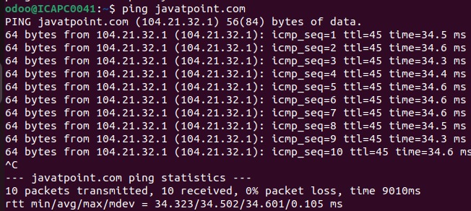

**Ubuntu Operators**

**1.&:**

This command sends a process/script/command to the background.

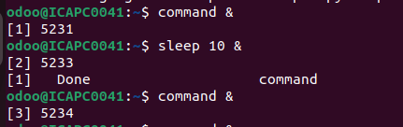

**2.&&:**

The command following this operator will only execute if the command preceding this operator has been successfully executed.

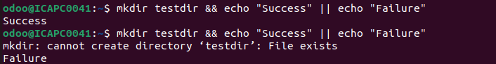

**3.|:**

The output of the first command acts as input to the second command.



**4.>,>>,<:**

Redirects the output of a command or a group of commands to a file or stream.

the “>” is the output redirection operator used for overwriting files that already exist in the directory. While, the “>>” is an output operator as well, but, it appends the data of an existing file. Often, both of these operators are used together to modify files in Linux.

**>,>>:**

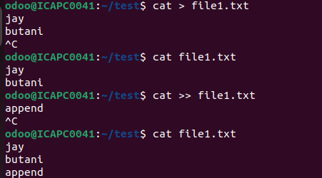

**<:**

The < operator is used to redirect input from a file or another source to a command. It tells command to read input from the specified file instead of the standard input.

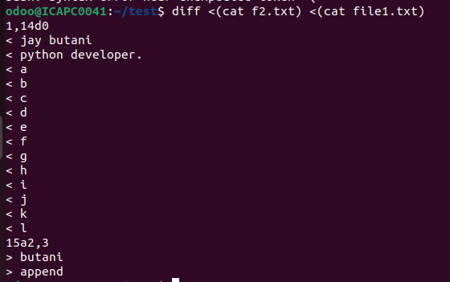

**5.\:**

The backslash can escape spaces in file or directory names to prevent the shell from treating them as seprate arguments.

The backslash can escape single or double quotes to include them in a string.



**6.*:**

In the shell, * acts as a wildcard character, matching zero or more characters in filenames or patterns. For example:

* ls *.txt lists all files ending in .txt.



In arithmetic expressions within the shell or scripts, * represents the multiplication operator. For example:

* echo $((2 * 3)) outputs 6.



**7.^:**

The ^ operator is used to math the beginning of a line or string in regular expression.

